Site Surveying & Set Out 1
Volume calculation
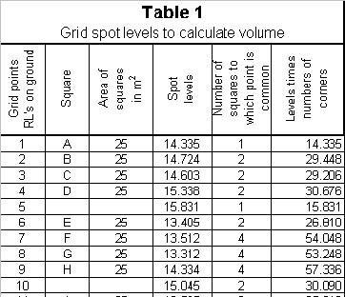Step 1
Sum up the column 5 & 6 and find the mean height (MH) by dividing the sum of the levels by the sum of the number of common points.
Step 2
Find the difference between the mean height (MH) and the proposed finish ground level (FGL).
a) the difference can be positive (+ve) or negative (-ve).
b) if the mean height is greater (+ve) than the finish ground level (FGL) then it is a cut.
c) if the mean height is smaller (-ve)
than the finish ground level (FGL) then it is a fill .
MH < FGL = FILL
MH > FGL = CUT
MH = FGL then CUT = FILL
Step 3
Multiply the difference (from Step 2) with the area of the lot to find the required volume.

